
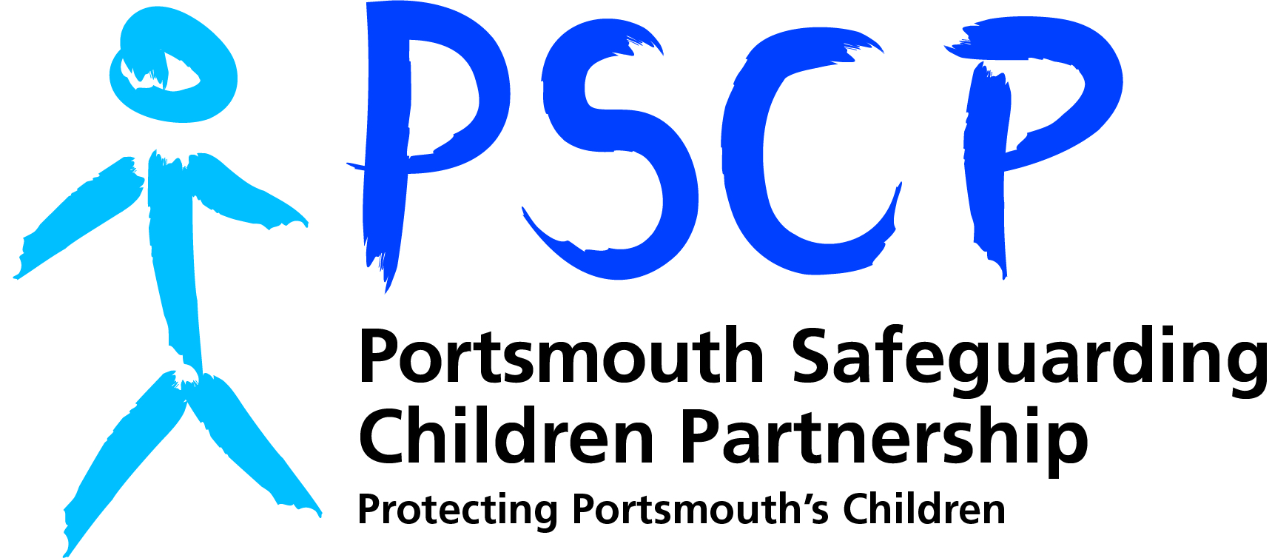

Referral Form for
Safeguarding Adult Review or Child Safeguarding Practice Review

**Please note: this form is not to be used to refer for services (including referrals to MASH). It is only to be used to refer to the Portsmouth Safeguarding Adults Board/Portsmouth Safeguarding Children Partnership for multi-agency review**

When completed please send this referral form as a password protected document to one of the following addresses:
If you are completing this form to request consideration of a case involving an adult, please email it to: psab@portsmouthcc.gov.uk
If you are completing this form to request consideration of a case involving a child, please send via secure email to: PSCP@portsmouthcc.gov.uk

The criteria to commission a Safeguarding Adult Review or a Child Safeguarding Practice Review are as follows:
Child Safeguarding Practice Review (Chapter 4 Working Together March 2018)
When a serious incident becomes known to the safeguarding partners, they must consider whether the case meets the criteria for a local review:
- Abuse or neglect of child is known or suspected and
- The child has died or been seriously harmed
Meeting the criteria does not mean that we must automatically carry out a Local Child Safeguarding Practice Review. We must determine whether a review is appropriate, taking into account that the overall purpose of a review is to identify improvements to practice.
Does the case highlight the following with regard to safeguarding children and promoting their welfare:
- Improvements that need to be made?
- Recurrent themes?
- Concerns regarding how one or more agencies worked together?

Safeguarding Adult Review (Section 44 Care Act 2014)
(1) A SAB must arrange for there to be a review of a case involving an adult in its area with needs for care and support (whether or not the local authority has been meeting any of those needs) if:
- There is reasonable cause for concern about how the SAB, members of it or other persons with relevant functions worked together to safeguard the adult, AND
- Condition 1 or 2 is met.
(2) Condition 1 is met if:
- The adult has died, AND
- The SAB knows or suspects that the death resulted from abuse or neglect (whether or not it knew about or suspected the abuse or neglect before the adult died).
(3) Condition 2 is met if:
- The adult is still alive, AND
- The SAB knows or suspects that the adult has experienced serious abuse or neglect.
(4) A SAB may arrange for there to be a review of any other case involving an adult in its area with needs for care and support (whether or not the local authority has been meeting any of those needs).
(5) Each member of the SAB must co-operate in and contribute to the carrying out of a review under this section with a view to:
(a) Identifying the lessons to be learnt from the adult’s case, and
(b) Applying those lessons to future cases.

1. Referral Details
Referrer’s Name & Role
Agency
Tel. No.
Email
Date of Referral
If there has been a delay in referral, please note the reason
State if referral is for a SAR or CSPR
Details of any other review, or investigation e.g. SIRI, criminal investigation, DHR etc.

2. Details of Subject
Full name
Any other known names
Date of Birth
Date of death or incident leading to serious abuse/harm being caused
Place of death/ serious incident
Ethnicity
Gender
Current address
Previous address
School / Nursery / Residential Home / Care Home etc. (if applicable)

3. Details of Significant Persons e.g. parent, carer, sibling, son, daughter etc.
(complete additional row for each additional significant person)

Full Name | Date of Birth | Address | Relationship to Subject

4. Agencies known to be involved with the Subject
Please list the names of all services you know to be involved with the subject, including the name of the relevant professional and their job role where possible:

5. Reasons for Referral
- Reasons for Referral for Safeguarding Adult Review (please tick)
Adult with needs for care and support
Concern about multi agency working
Adult has died AND death linked to abuse or neglect.
Please also specify type of abuse or neglect:
- Physical |  | - Discriminatory
- Sexual |  | - Domestic abuse
- Psychological |  | - Organisational abuse
- Financial or material |  | - Modern slavery
- Neglect and acts of omission |  | - Self-Neglect
Adult is alive having experienced serious abuse or neglect.
Please specify type of abuse or neglect:
- Physical |  | - Discriminatory
- Sexual |  | - Domestic abuse
- Psychological |  | - Organisational abuse
- Financial or material |  | - Modern slavery
- Neglect and acts of omission |  | - Self-Neglect
Other reason (specify)
- Reasons for Referral for Child Safeguarding Practice Review (please tick)
Abuse or neglect of a child is known or suspected.
A child has died (including suicide)
A child has been seriously harmed
Concern about multi agency working
Other reason (specify)

6. Case Outline
Please give a brief summary of the circumstances of this case (we do not require case notes or a chronology at this stage) and explain why you feel this case should be considered for a safeguarding adult review or child safeguarding practice review. Please describe any concerns around multi-agency working that you may be aware of. If the case were not to meet the statutory criteria for review, please describe why a discretionary review would be beneficial.

